**Name:** Nnadiekwe David Chiderah

Internet-facing Load Balancer with Public Subnet – Scalability and Resilience

find user data script at the bottom.

**Step 1:** Create ALB and Webserver Security Group —–> “alb_sg” and “web_sg” alb_sg should allow 0.0.0.0/0 on port 80.

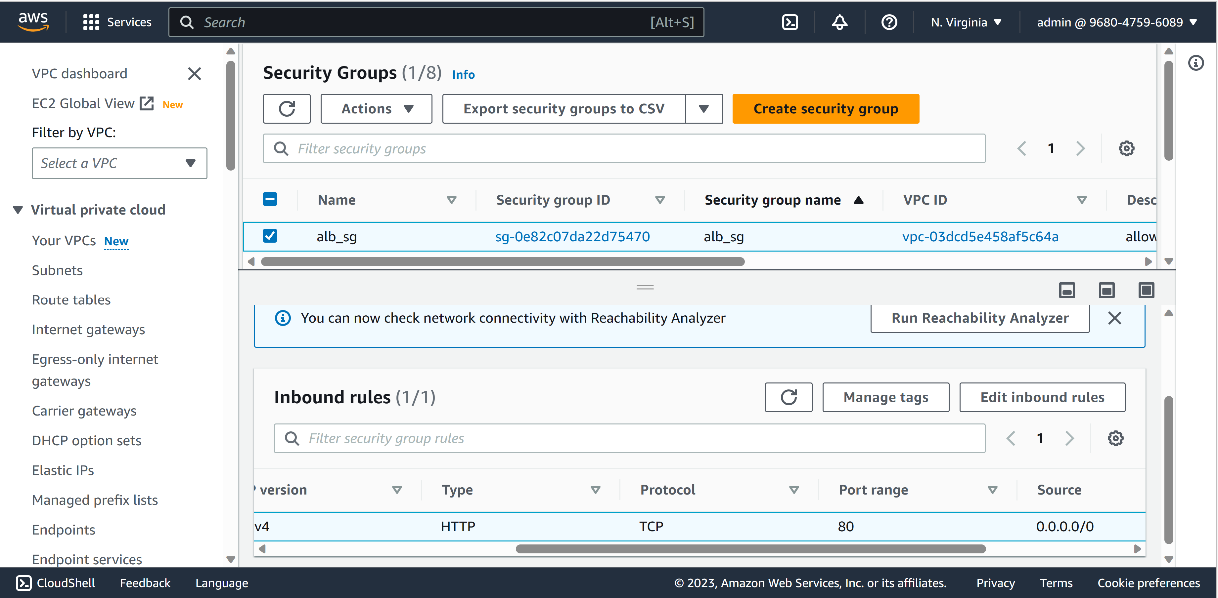

web_sg should allow alb_sg on port 80

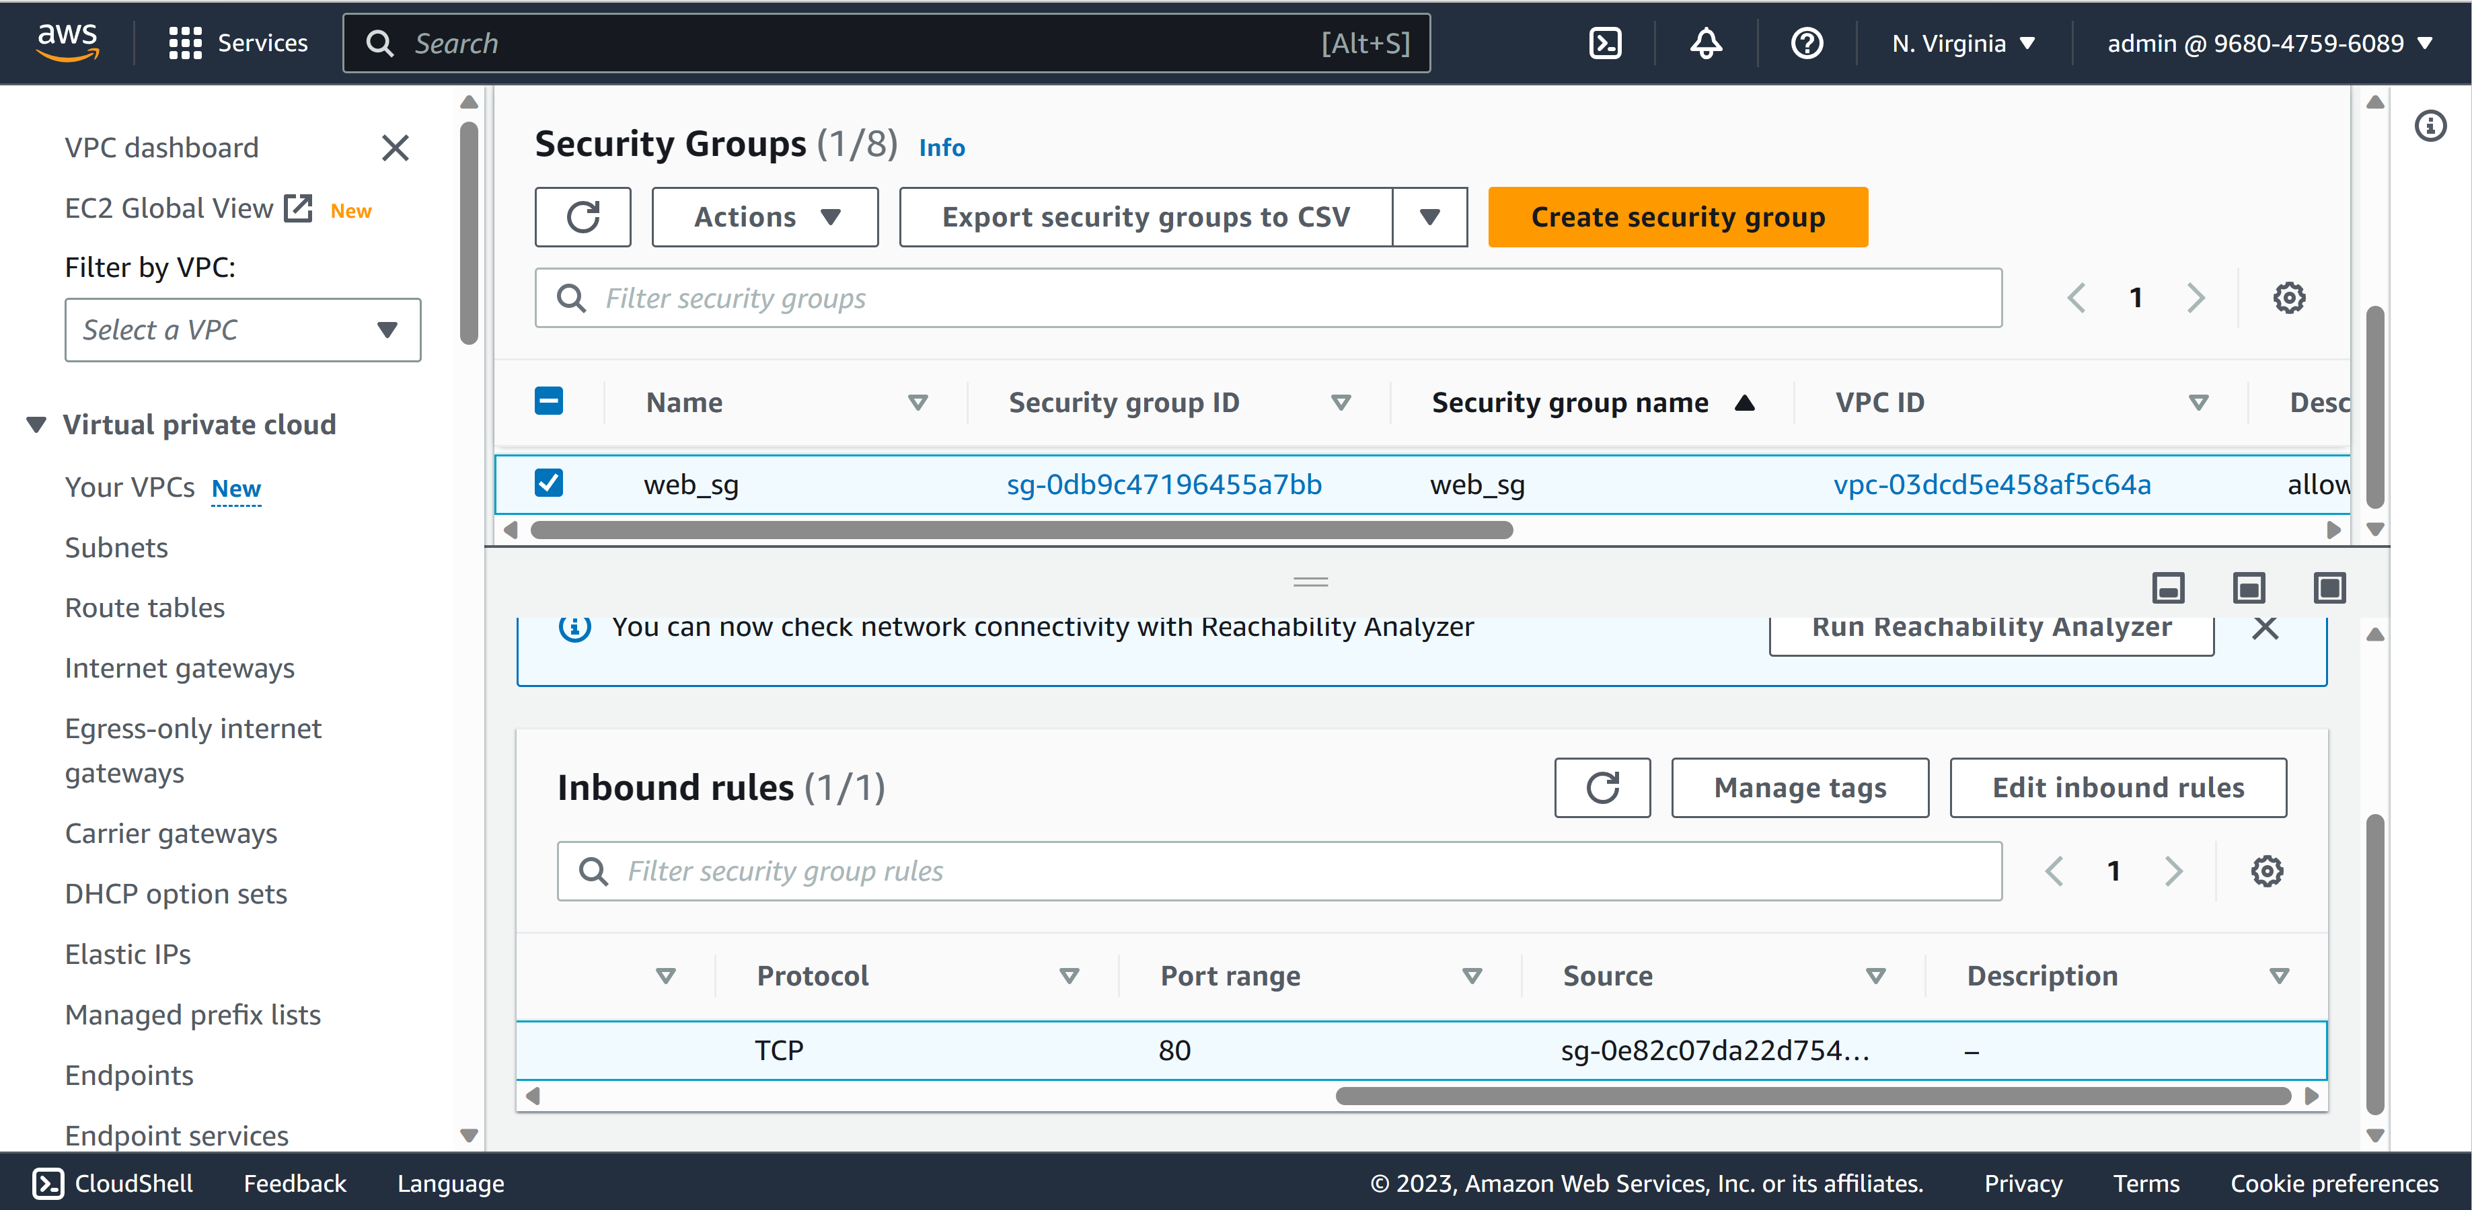

**Step 2:** Create your Public webservers Image —–> tag: image_server_1 and tag: image_server_2

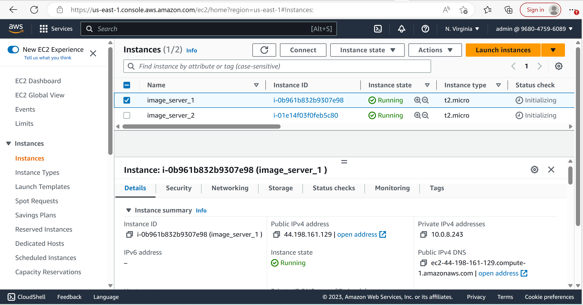

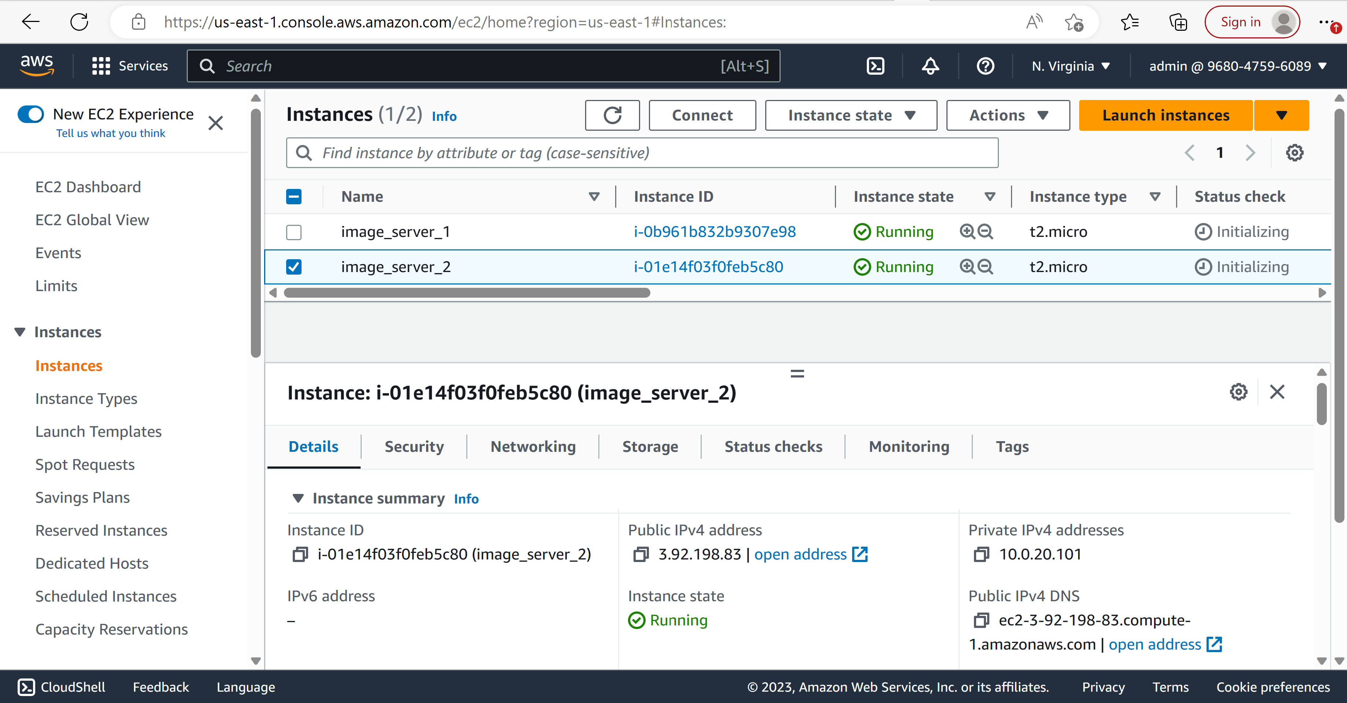

test using public ip address

take screenshot showing timeout of both in the browser

Testing web server 1:

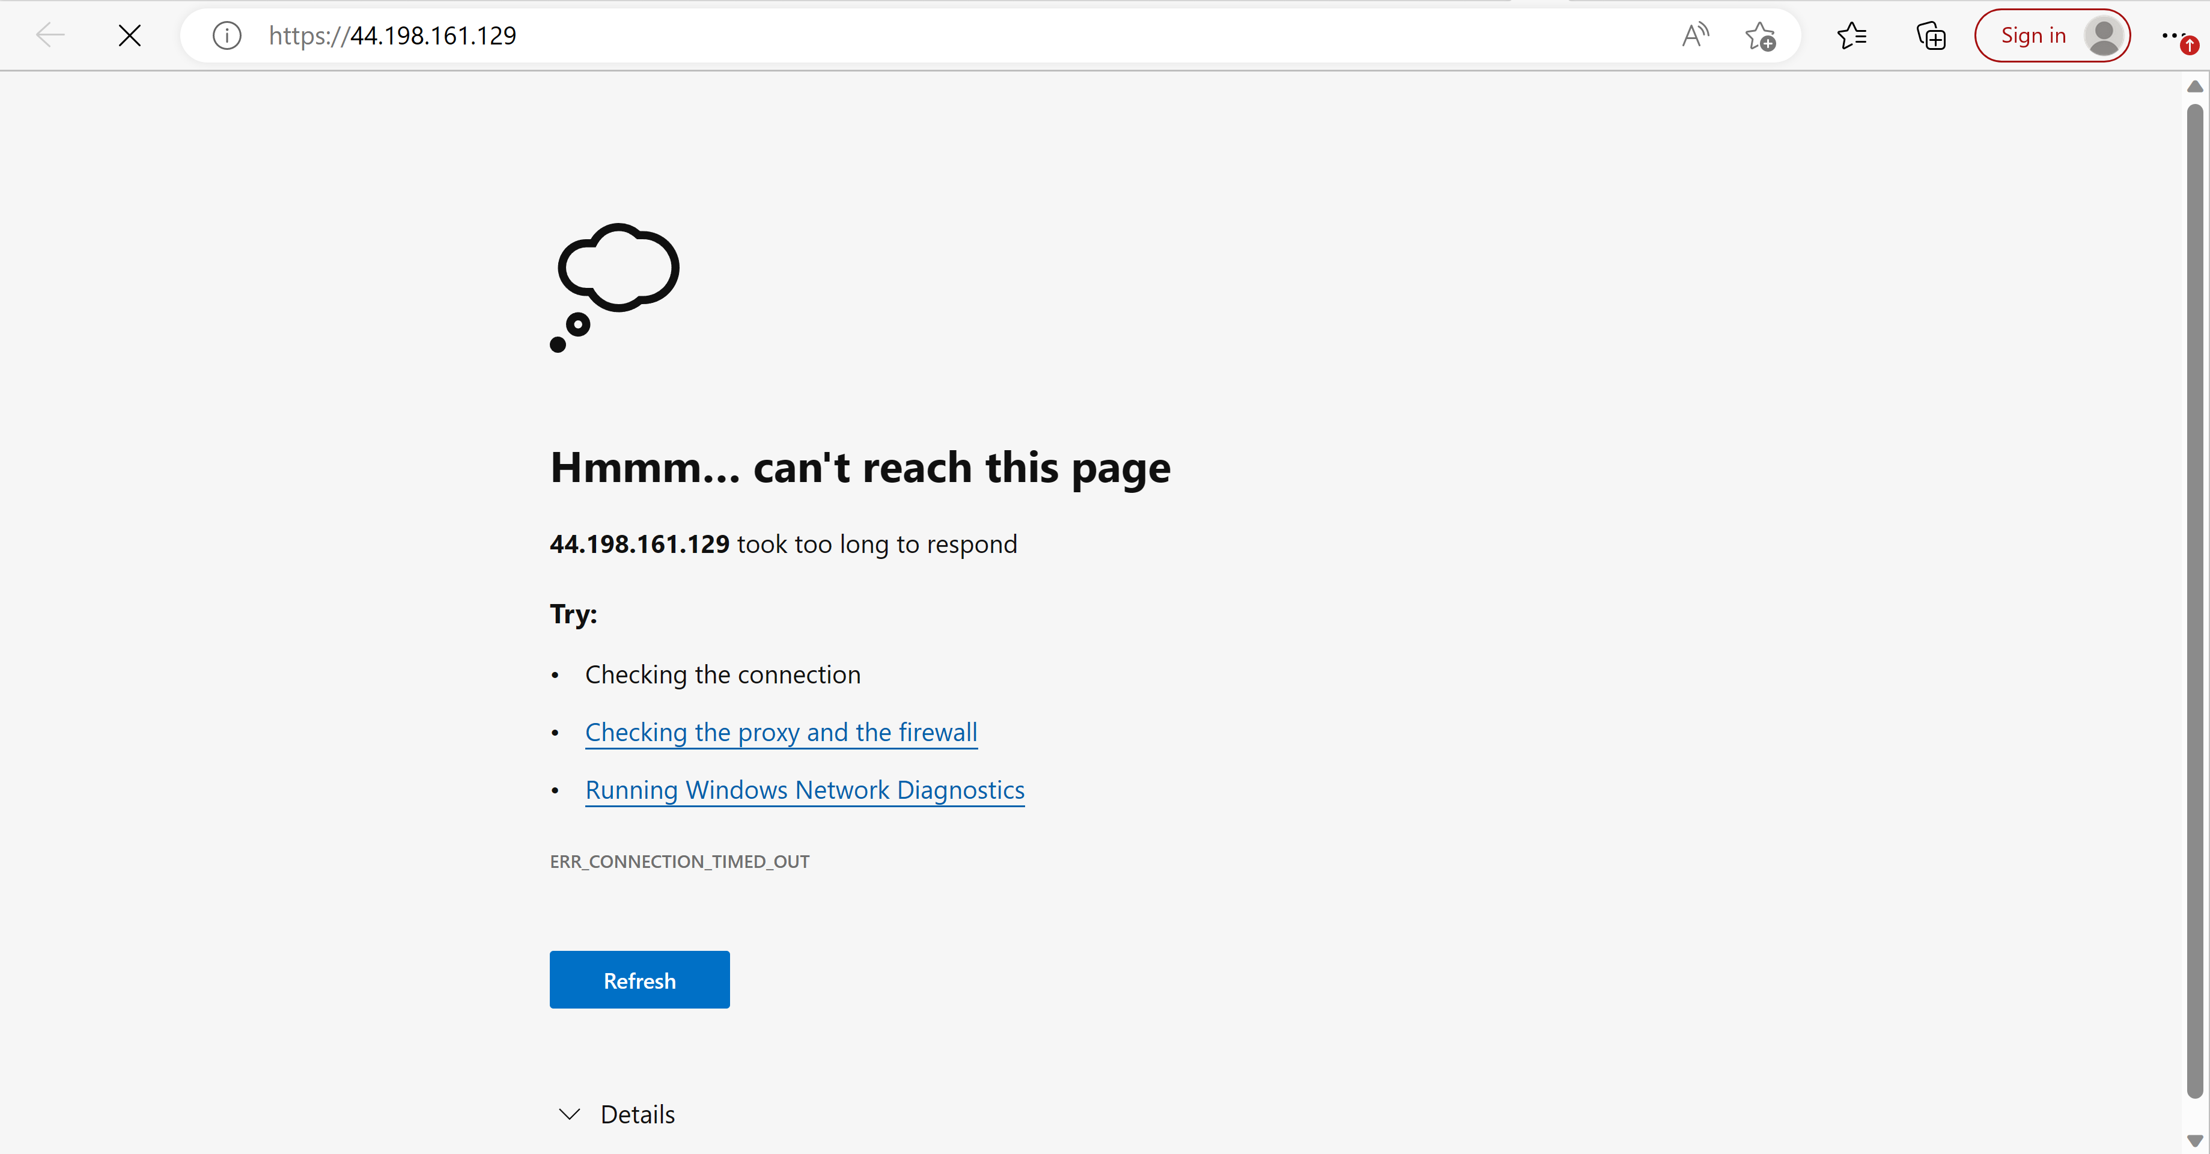

Testing web server 2:

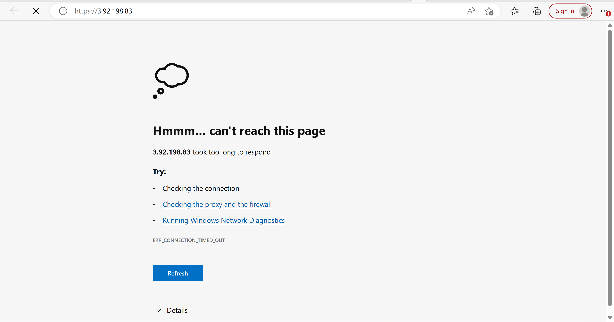

**Step 3:** Create Target Group with targets (Webservers) —–> name: “may2022class-tg”

please observe the status

take screenshot showing “Health status details”

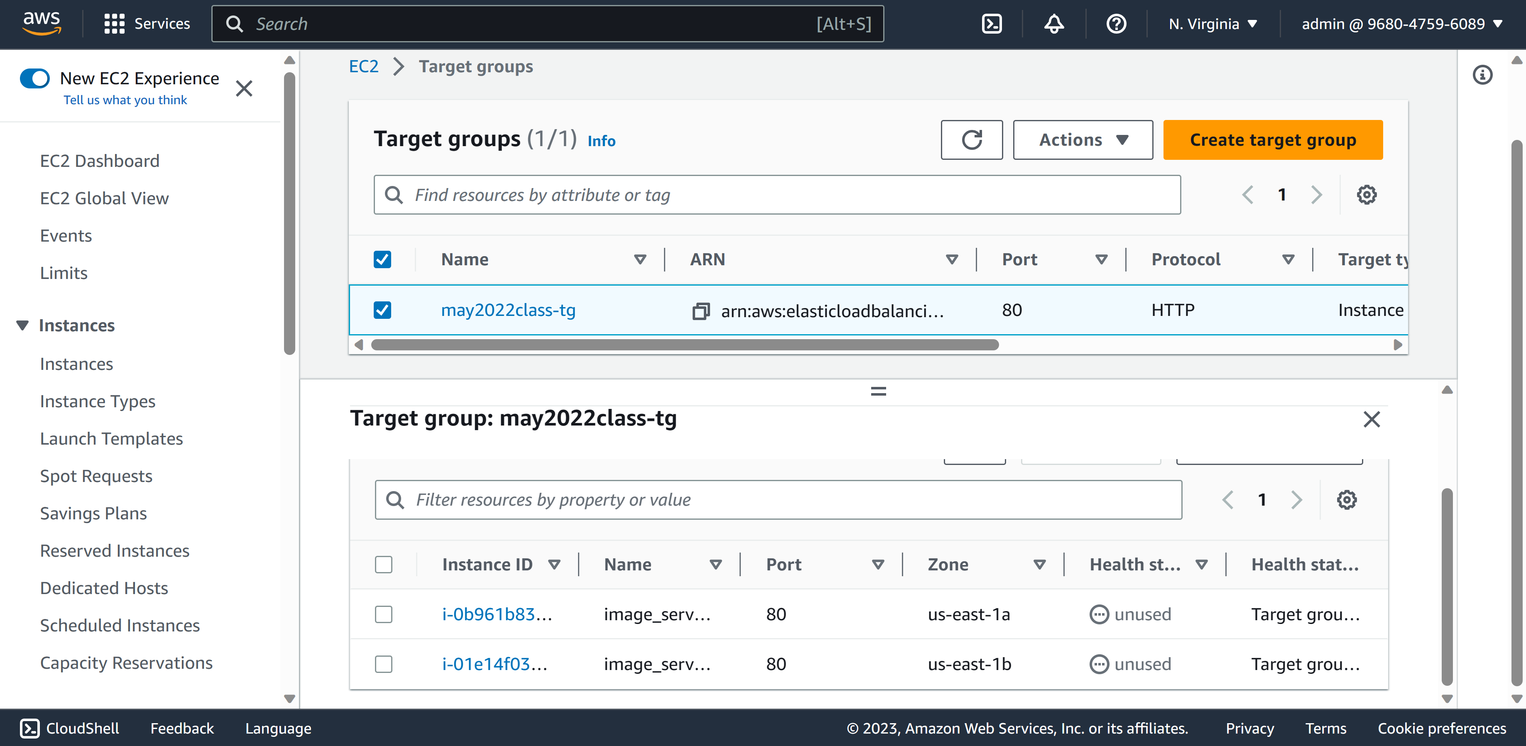

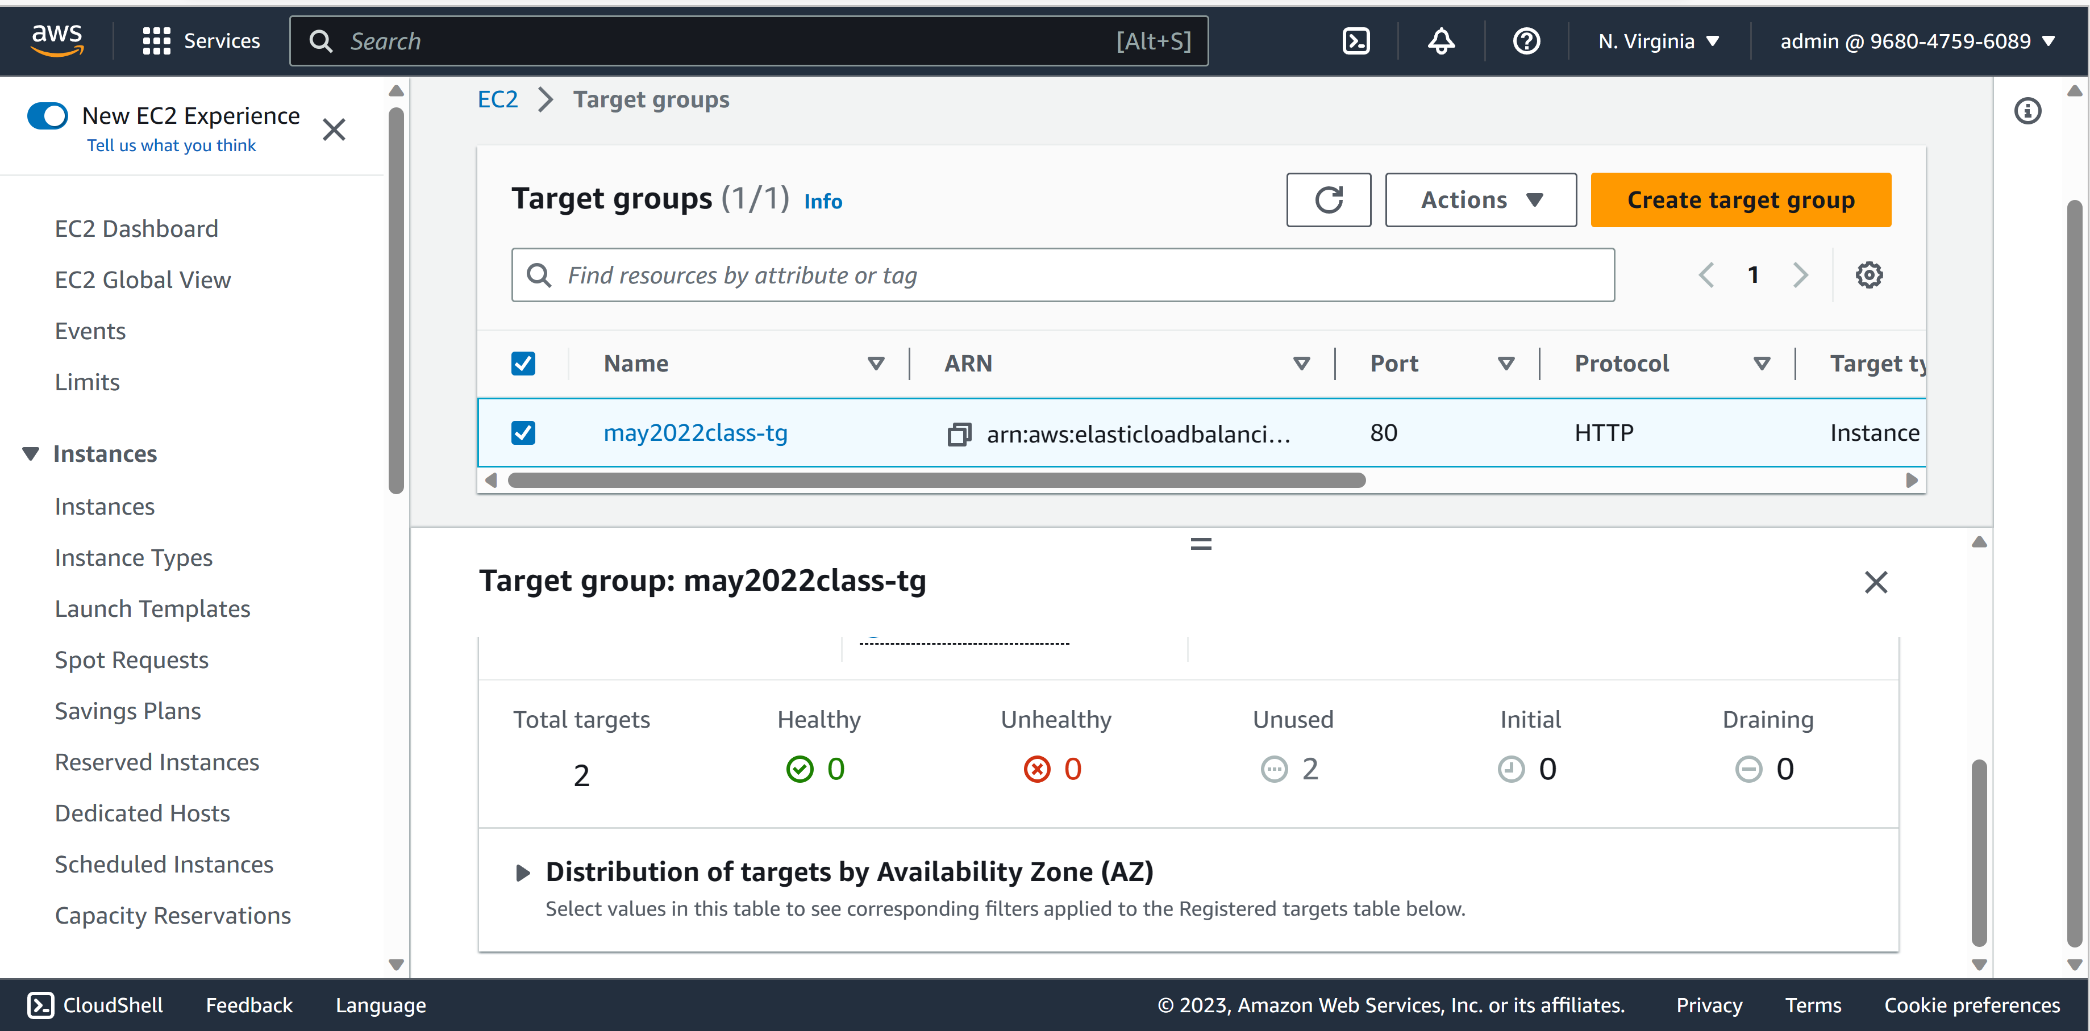

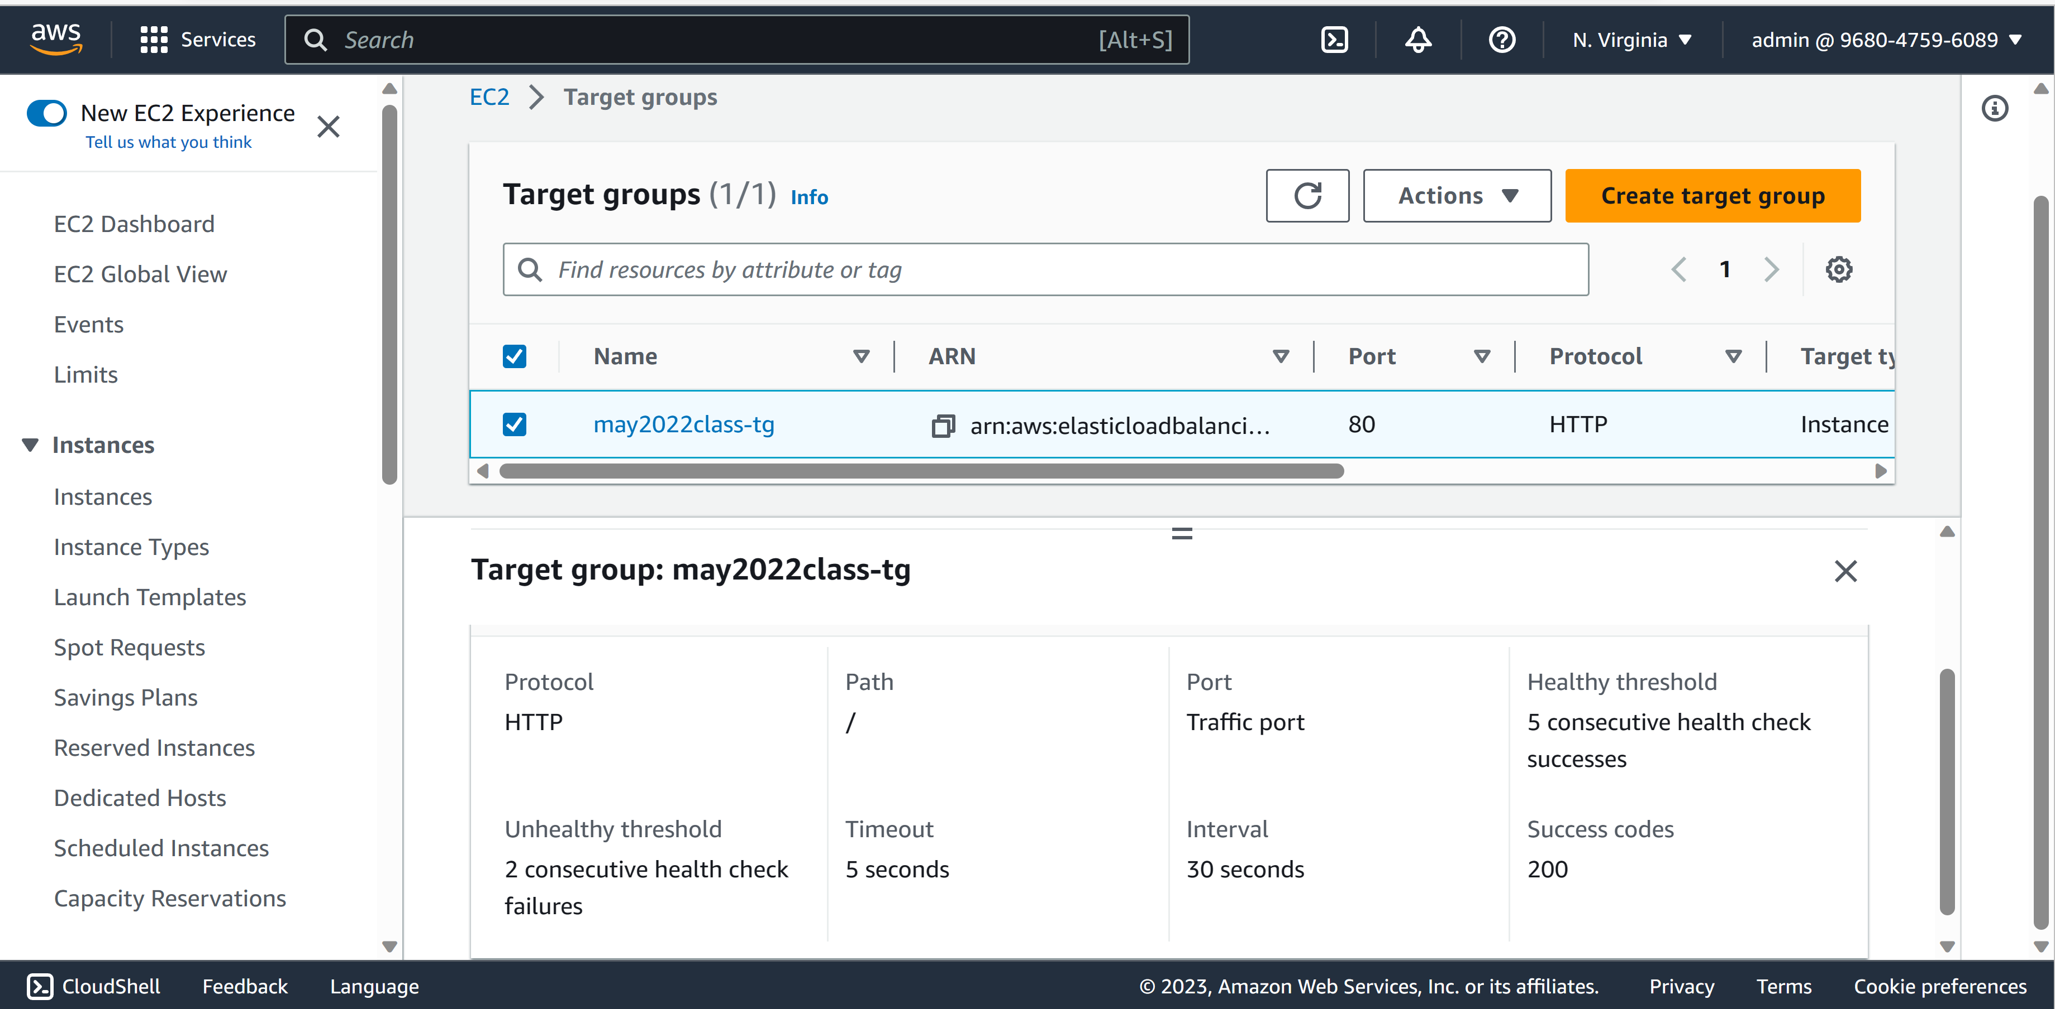

**Step 4:** Create an Application Load Balancer (ALB) —–> name: “may2022class-alb”

listener on http (80) only

select may2022class-alb > click on Listener and take a screenshot.

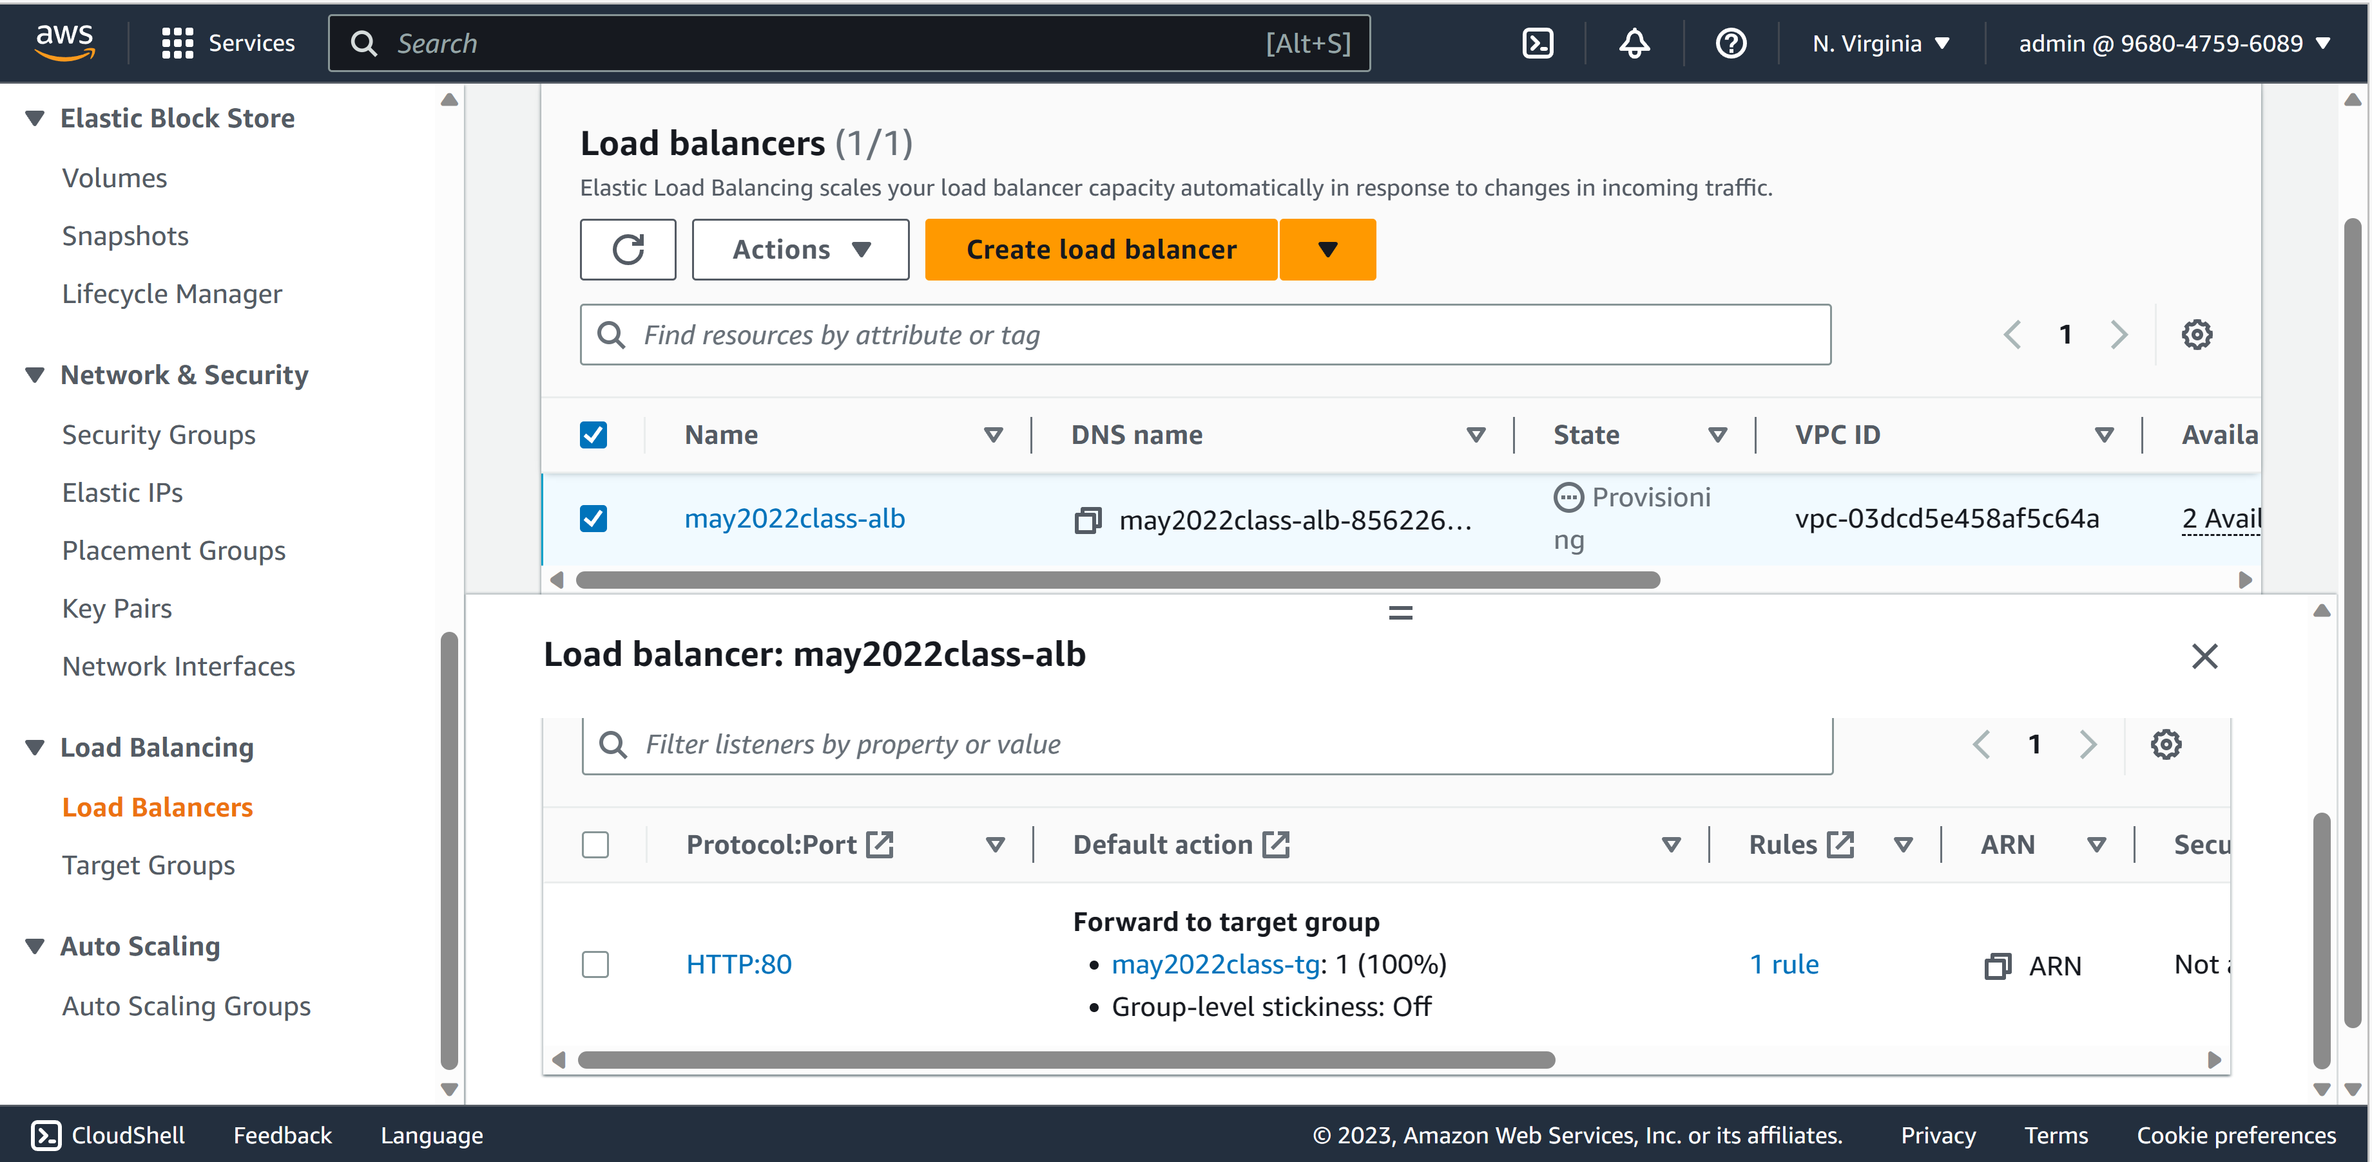

**Step 5:** Observe the target group status again in the console

take a screenshot when it shows healthy

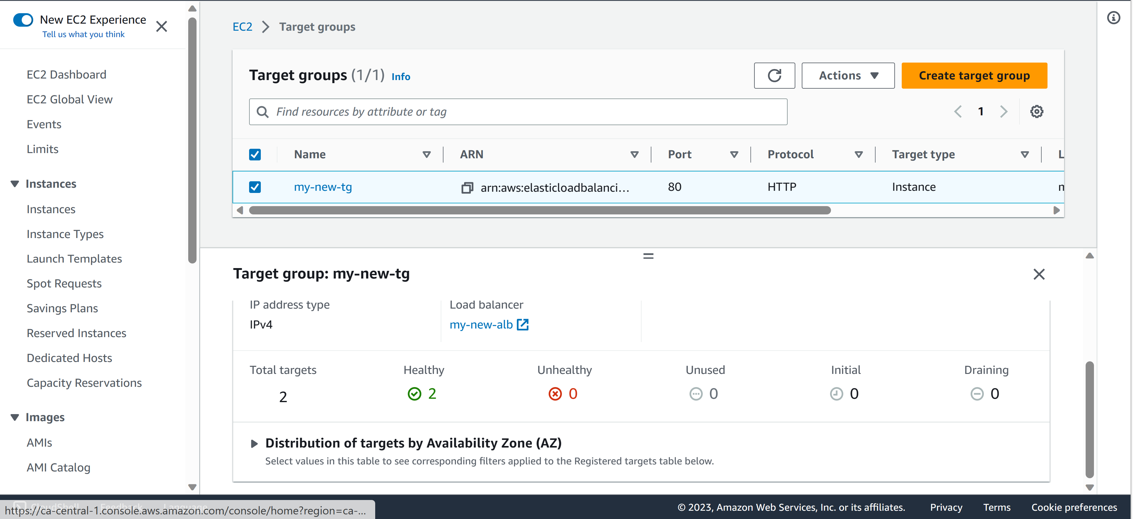

**Step 6:** test your website in a browser using the ALB dns name and refresh multiple time

take screenshots of both Blue and Red

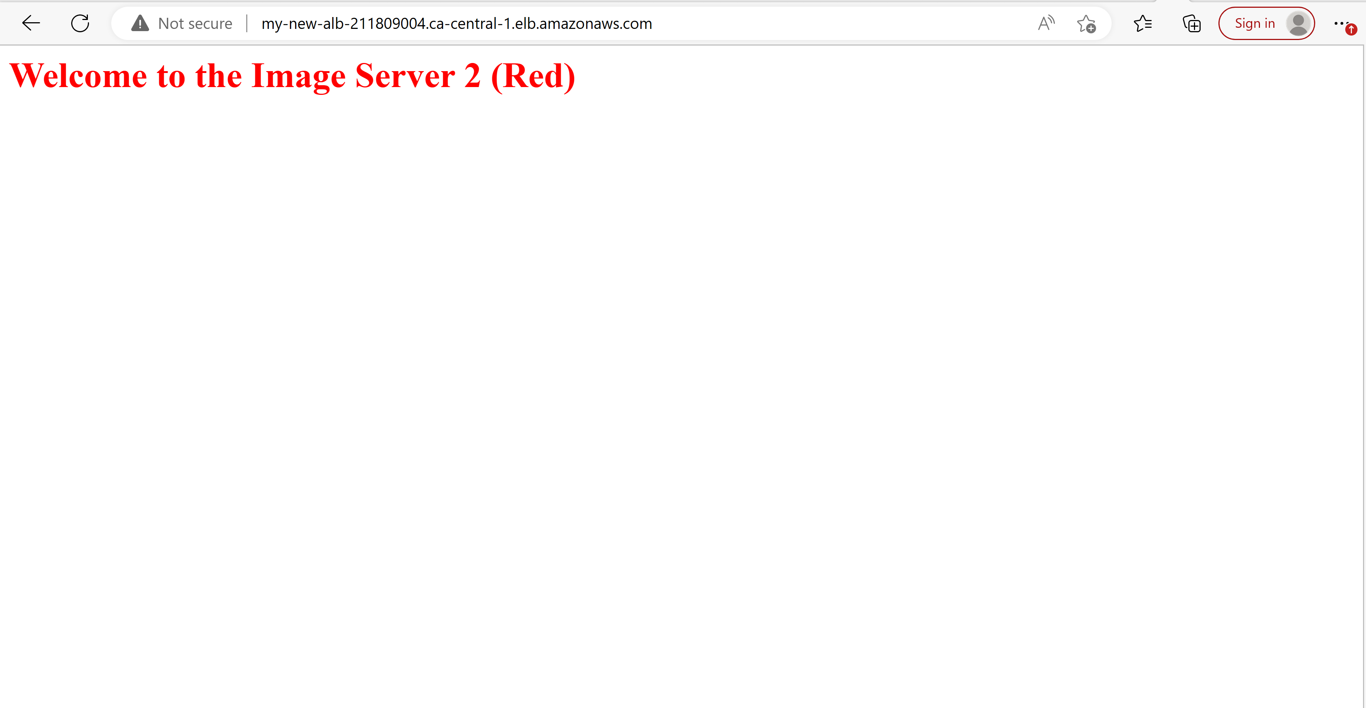

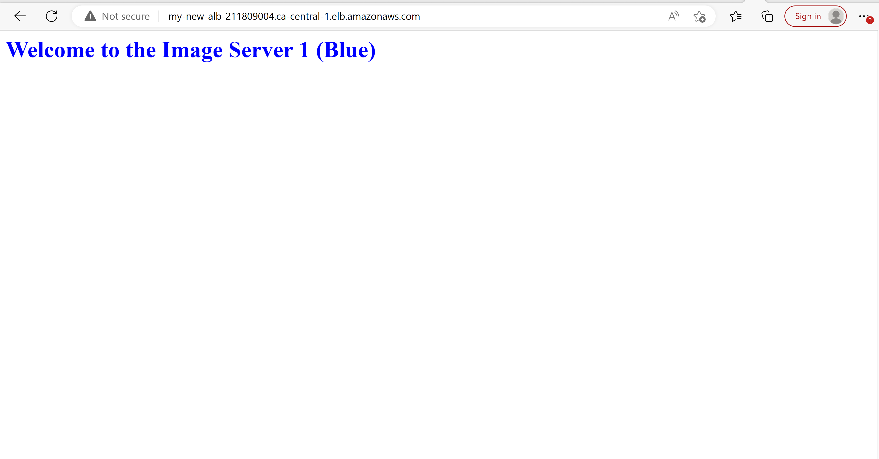

**Step 7:** stop webserver 1 and test again to see which server is now responding

take a screenshot

I stopped server 1

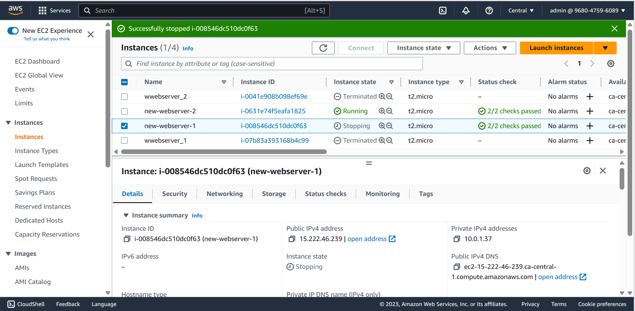

Only the red server (server 2) responded

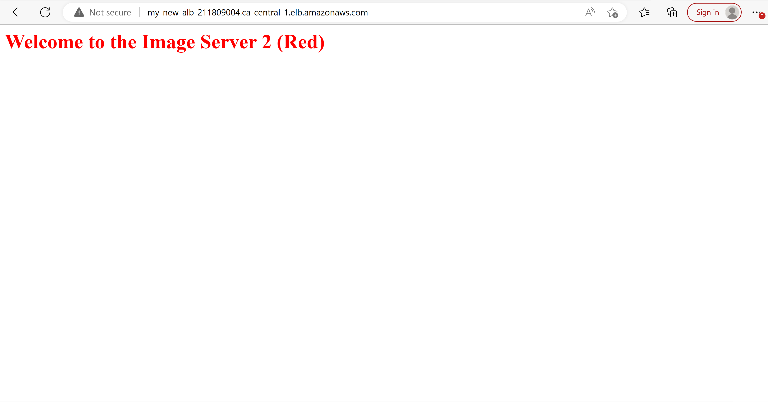

**Step 8:** clean up your environment by deleting in the reverse order that you created all resources

take screenshots of both Blue and Red

I deleted the Load balancers

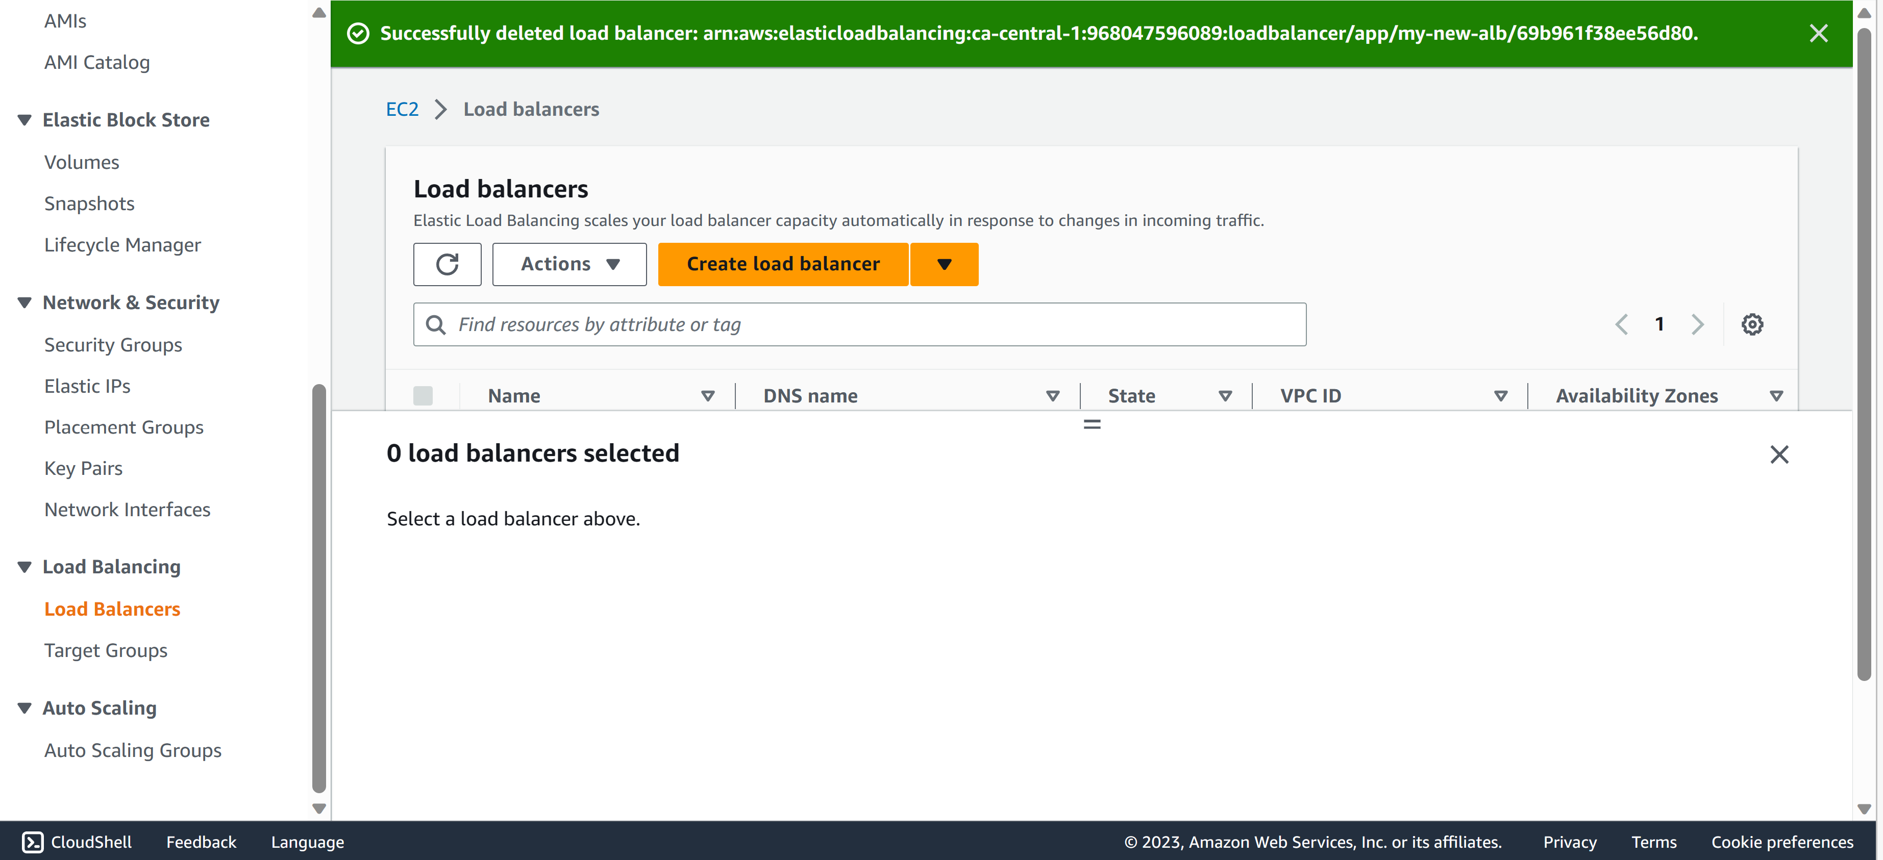

I deleted the target group

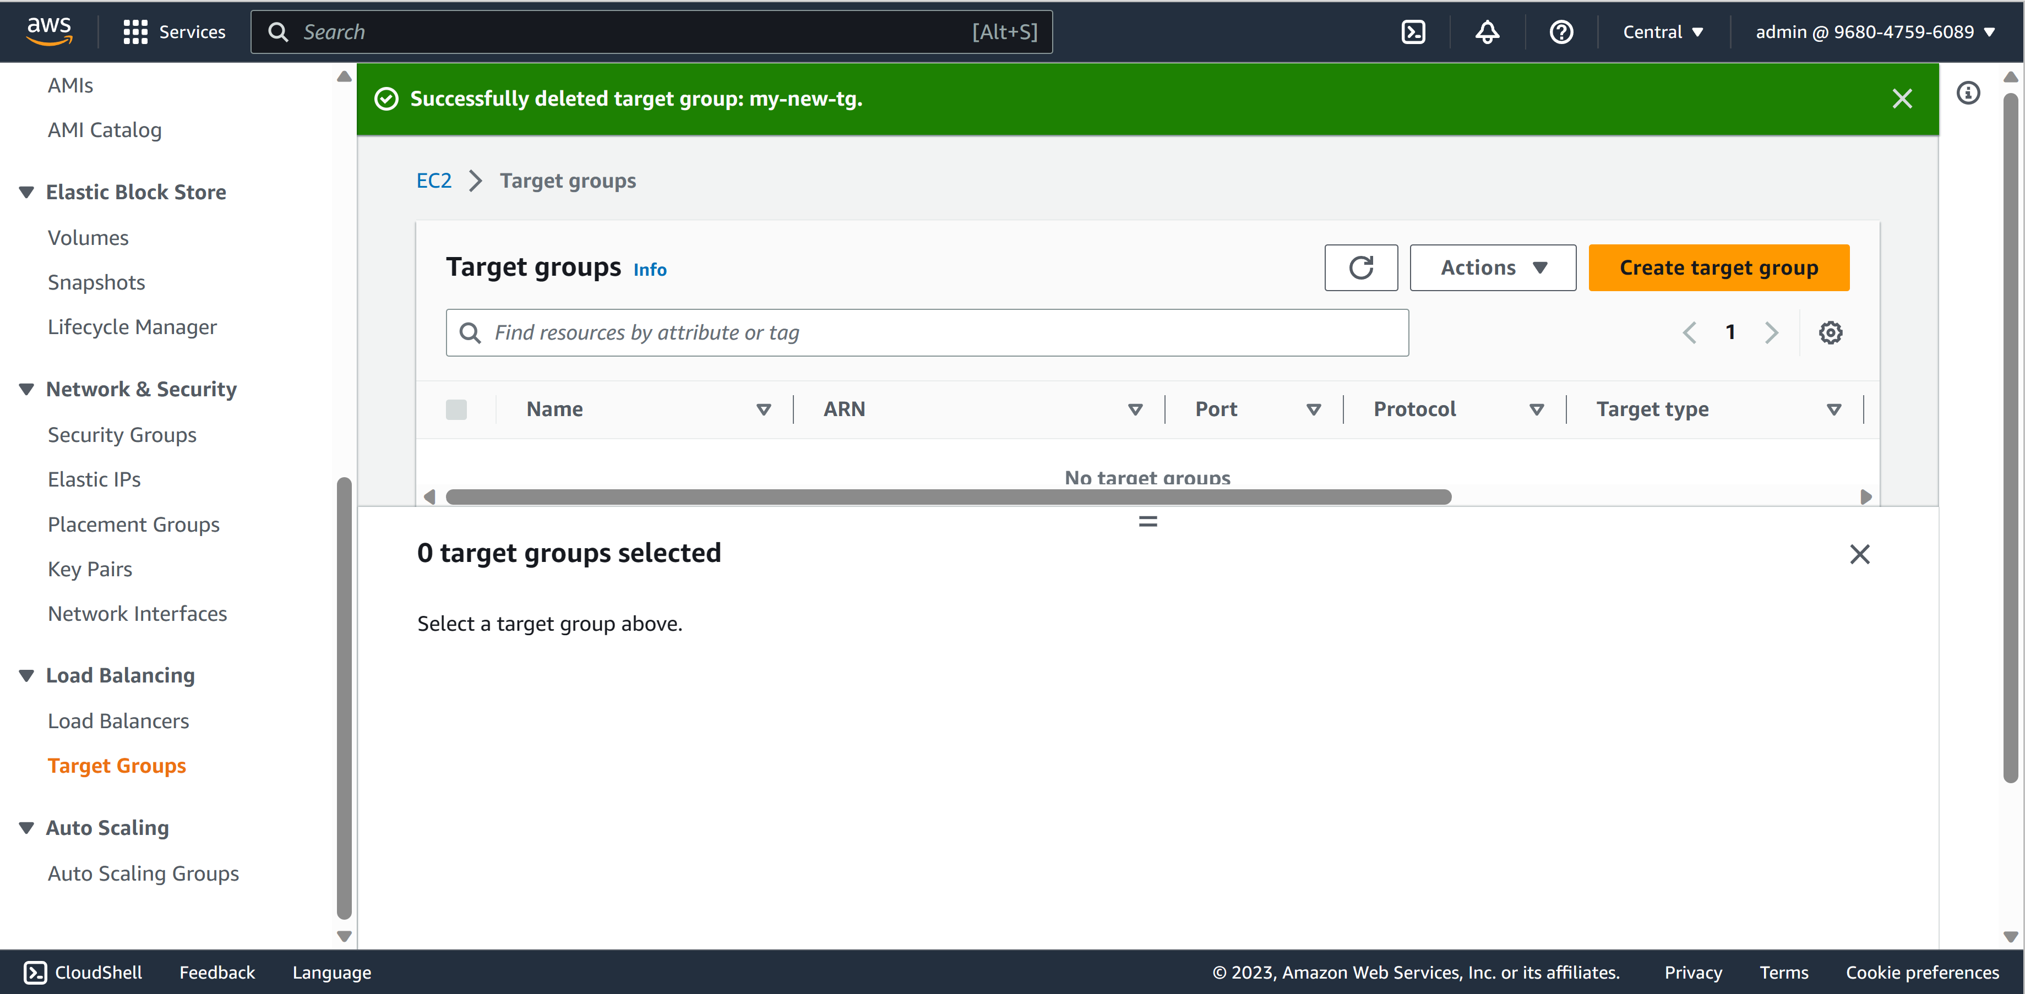

I terminated the instances

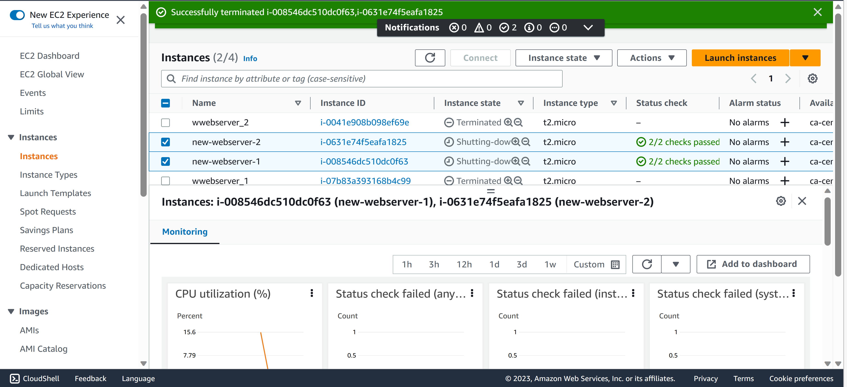

I deleted the VPCs

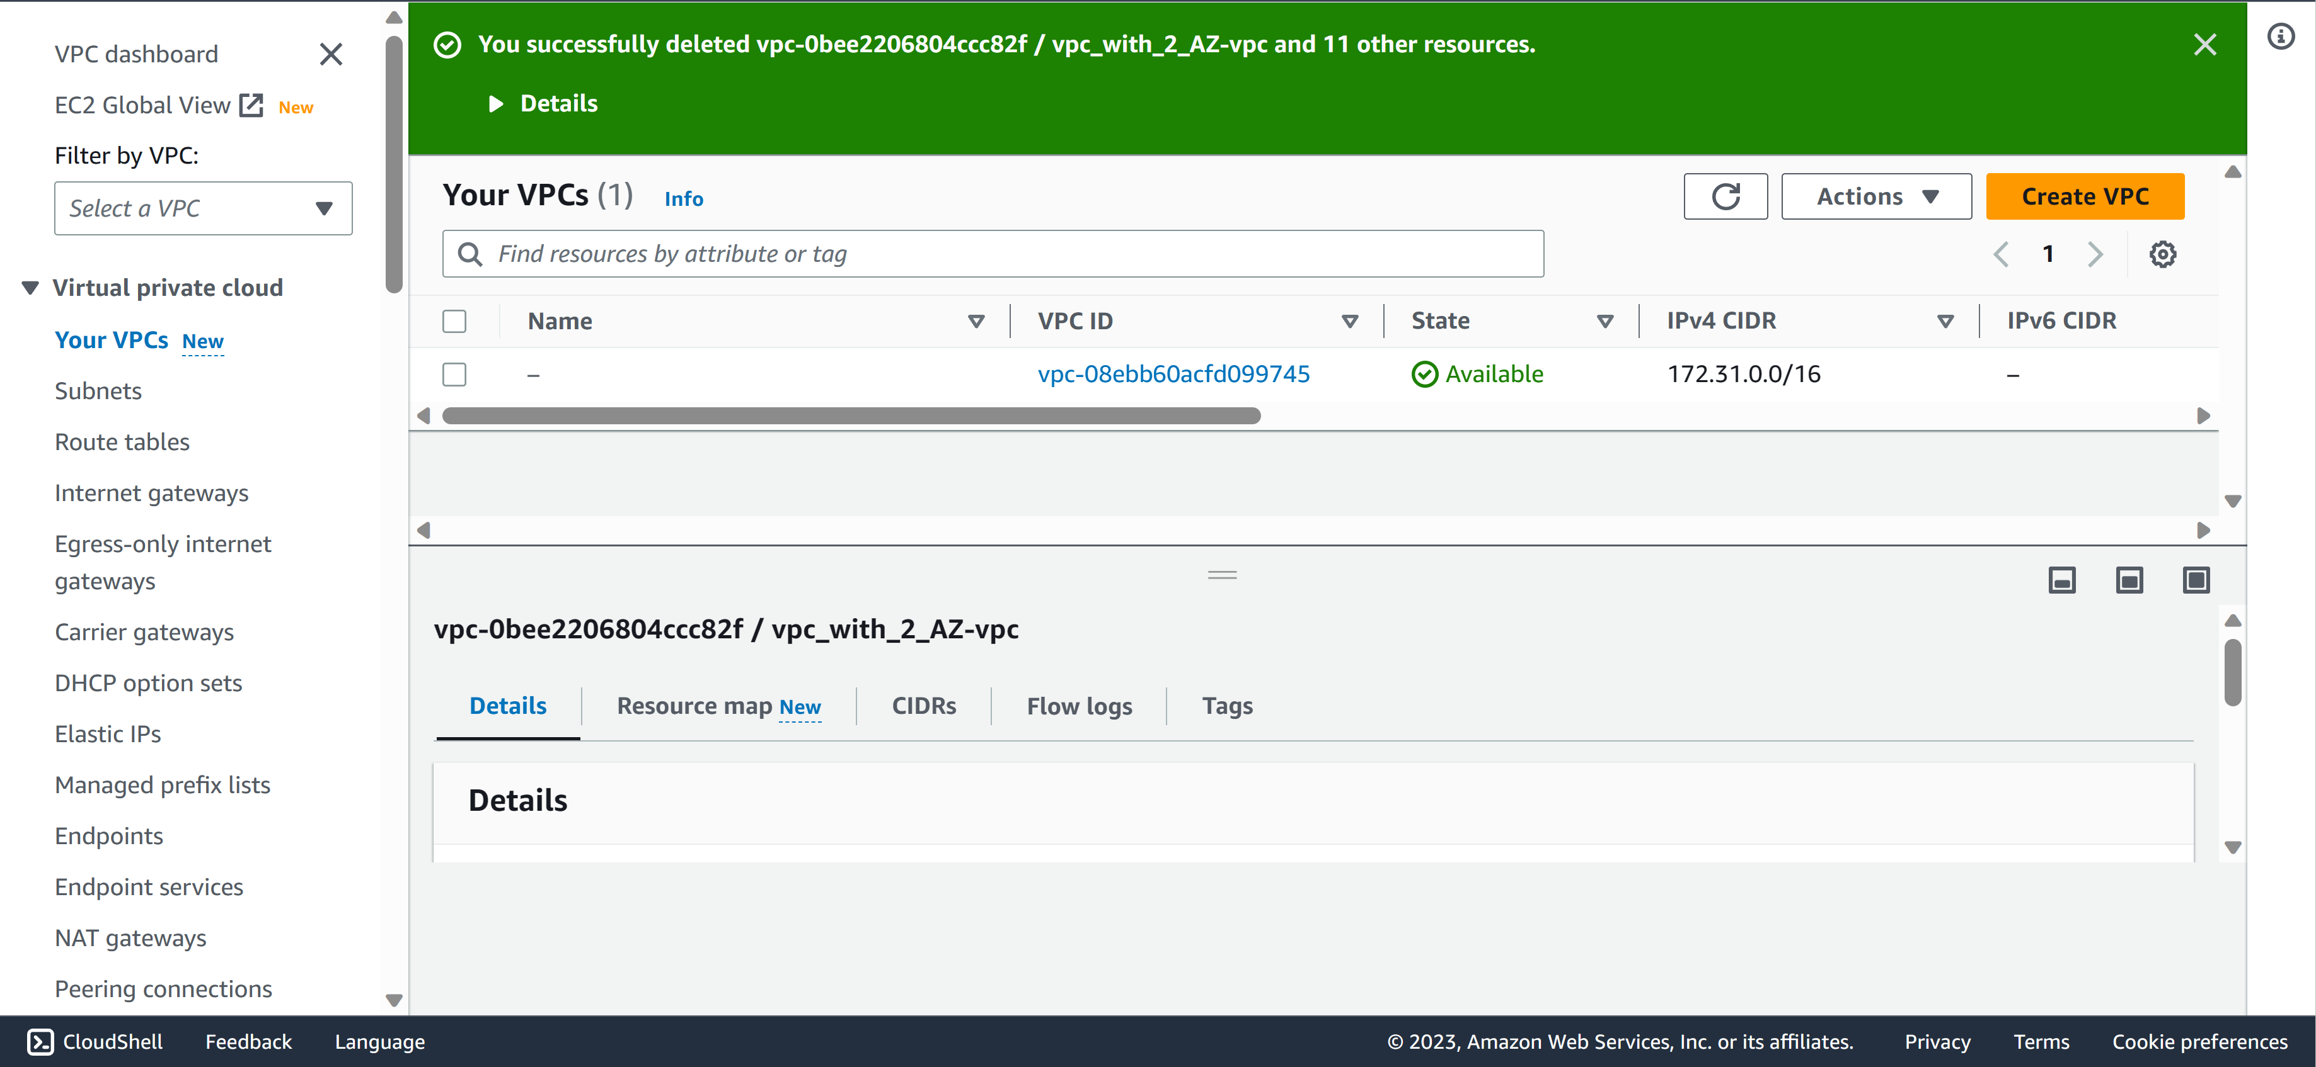

**Using the Private subnet for this purpose**

Internet-facing Load Balancer with Public Subnet – Scalability and Resilience

**Step 1:** Create ALB and Webserver Security Group —–> “alb_sg” and “web_sg” alb_sg should allow 0.0.0.0/0 on port 80.



web_sg should allow alb_sg on port 80



**Step 2:** Create your Public webservers Image —–> tag: image_server_1 and tag: image_server_2





test using public ip address

take screenshot showing timeout of both in the browser

Testing web server 1:



Testing web server 2:



**Step 3:** Create Target Group with targets (Webservers) —–> name: “may2022class-tg”

please observe the status

take screenshot showing “Health status details”







**Step 4:** Create an Application Load Balancer (ALB) —–> name: “may2022class-alb”

listener on http (80) only

select may2022class-alb > click on Listener and take a screenshot.



**Step 5:** Observe the target group status again in the console

take a screenshot when it shows healthy



**Step 6:** test your website in a browser using the ALB dns name and refresh multiple time

take screenshots of both Blue and Red





**Step 7:** stop webserver 1 and test again to see which server is now responding

take a screenshot

I stopped server 1



Only the red server (server 2) responded



**Step 8:** clean up your environment by deleting in the reverse order that you created all resources

take screenshots of both Blue and Red

I deleted the Load balancers



I deleted the target group



I terminated the instances



I deleted the VPCs

